**COMSATS University Islamabad (CUI)**

**Project Proposal**

**for**

**Project Title**

A i r w o r x

Version 1.0

***By***

**Tahir Saeed CIIT/SP20-BSE-092/ISB (Group Lead)**

**Syed Huzaifa Bukhari CIIT/SP20-BSE-089/ISB**

**Mamoon Abbasi CIIT/SP20-BSE-064/ISB**

***Supervisor*Mr. Basit Raza**

***Bachelor of Science in Software Engineering (2020-2024)***

**Table of Contents**

Abstract 2

1. Introduction 3

2. Problem Statement 4

3. Problem Solution/Objectives of the Proposed System 4

3.1 Objectives 5

4. Related System Analysis/Literature Review 5

5. Vision Statement 5

6. Scope 6

7. Modules 5

8. System Limitations/Constraints 7

9. Data Gathering Approach 8

10. Tools and Technologies 8

11. Project Stakeholders and Roles 8

12. Module based Work Division 9

14. Mockups 10

15. References

16. Plagiarism Report

**Project Category:**

□ **A-**Desktop Application/Information System ☑ **B-**Web Application/Web Application based Information System ☑ **C-**Problem Solving and Artificial Intelligence ☑ **D-**Simulation and Modeling □ **E-**Smartphone Application

□ **F-**Smartphone Game □ **G-**Networks ☑ **H-**Image Processing□ Other (specify category) ________________

# Abstract

In the aftermath of a disaster, such as earthquake, flood, or avalanche, ground search for survivors is usually hampered by unstable surfaces and difficult terrain. Drones can play an important role in these situations, allowing the rescuers to locate the survivors and accumulate the damage in the area. The recent disasters have shown how important it is for us to be equipped with the advanced technology to locate the survivors, recent events have shown that the search operations for survivors is a challenge for rescuers in conditions when contact with a survivor is difficult, potentially unsafe, and very stressful task, leading to cognitive and physical fatigue

The aim of this system is to explore the utility of a drone equipped for human life detection with a novel computer vision system. The proposed system uses image sequences captured by a drone camera to remotely detect the gesture motions caused by periodic movement of the survivors.

The proposed system will allow users to locate survivors and report the responsible authorities much quicker than in the current system. AI-Drone will automate the several manual processes to simplify the work in many aspects like locating the rescuers, accumulating the damage cost and people affected and enable its user to get a better overview of the disaster in a very sufficient time.

# Introduction

In the case of disaster relief, the search operation and damage cost accumulation are quite challenging task and that being done manually can be trickier. Recent advances in unmanned aerial vehicle (UAV), now synonymously, “drone” technologies will be suitable for this purpose and can help in the effort to search for living survivors in the aftermath of a disaster (Flood/Earthquake). Moreover, our system will allow the user to generate a detail report of the disaster comprehending all the aspects of calamity including damage cost, building/houses affected, people and livestock affected. The proposed system will include more in-depth features like measuring the height and area covered by a building to make sure it fits the government given regulatory and another useful feature is to locate a criminal using the novel computer vision technology, identifying its number plates of vehicles and faces of criminals. It will also help authorities to automatically detect fire like forest fires at initial stages before it spreads wider. The proposed system will be able to process live image and display the results in real time.

# Problem Statement

Current ground-based options for detecting humans, such as rescue robots, are expensive, require invasive equipment, and require a team of human operators to move around inside the search and rescue operation Furthermore, accessing a disaster zone is more difficult for rescue robots than for rescue workers and rescue dogs due to limited mobility of wheeled and tracked platforms. To address these challenges, we are developing a highly autonomous drone to assist first responders in their search to find survivors in disaster zones. These same issues apply when dealing with other aspects like measuring a building height and chasing down a criminal in a police chase and because of these problems in most cases the system either fails or prolongs the process until it has no more importance. The task of observing and analyzing humans from an aerial robot also known as the drone in outdoor environments has been of interest to the computer vision community for the last decade. Techniques to address the problem of estimating human pose and trajectory from the sky have been suggested.

# Problem Solution/Objectives of the Proposed System

Airworx is an AI based system which will have multi-dimensional uses in practical life. There are a lot of drones in the market which are used for various purposes but by integrating AI with existing systems will make things more efficient and much advanced. The proposed system is going to be very useful for daily tasks which are being done manually this will be useful in many fields from crime control to construction, from surveillance to disaster management it will help people and make all the processes much easier and accurate. This system will be using AI on the footages of drone, and it will carry multiple functionalities with those footages. System will have certain different tasks which it will carry out using image processing. The system will be designed to establish solutions for several challenges, including handling blurring in the captured images, data from multiple sources (e.g., drones or helicopters), the scarcity of labeled flood images (i.e., since disasters are uncommon), enabling the considered networks to work well on top-view images on which they are not originally trained as well as avoiding over-fitting to training data.

## Objectives

*BO-1: Reduce the manual work by 60%.*

*BO-2: Reduce the time of locating survivors by 70%*

*BO-3: Increase the average work time efficiency by 75%.*

# Related System Analysis/Literature Review

Table 1 Related System Analysis with proposed project solution

|  |  |  |
| --- | --- | --- |
| **Application Name** | **Weakness** | **Proposed Project Solution** |
| Building analytics comes built in some drones. | They are too expensive | It will cheaper as we will be working on the live feed rather than adding more hardware |

# Vision Statement

# For Disaster’s Loss estimation, Life sign detection, building’ structure analytics and crime control who want to estimate monetary loss caused by a disaster and want to find stranded people in the area affected by the disaster. It will also be useful for law enforcement agencies to find the identity of transgressors or track them down using facial recognition. Building structure analytics will be helpful for housing societies to check if buildings are specific to their requirements given to residents. The AI-Drone is web application that will take the live stream from a drone and perform tasks to get the desired results. unlike in current situations where everything must be carried out manually. By using our product, we can get the loss estimation on a large-scale ground within minutes, and we can reach the most remote areas to find the people that need dire help. By using our product Law Enforcement agencies can easily identify a suspect or lock on him in a chase or even to find him in a crowded place. By using our product Housing Society management can make sure that all houses and commercial plazas are meeting the requirements given by the housing society

# Scope

AI-Drone is basically adding more and more capabilities to the drone itself and getting best outcomes out of it by using computer vision on its live feed. User will login into web application and connect drone to our app. When live feed of Drone is connected to app, user can select from the menu of different aspects of this app such as Loss estimation due to Flood, Loss estimation due to Earthquake, Building analytics and Crime control. After the Flight is complete system will process the data and generate a thorough report on it.

# Modules

## User Profile Management

*FE-1: manage user’s information and access control.*

*FE-2: Allow users to sign in and signup with the system.*

## Disaster Management

**7.2.1**: **Flood Manager**

*FE-1: Flood depth and cost of damage calculation and detection using computer vision and generation of detailed report after completing aerial survey of area.*

*FE-2: Area affected by flood dimension detection using computer vision.*

*FE-3: Using computer vision and algorithms to detect people and survivors who need help during the disaster.*

**7.2.2**: **Earthquake Manager**

*FE-1: Using computer vision to detect the buildings and houses affected by the earthquake.*

*FE-2: Area affected by earthquake.*

*FE-3: Calculation of the cost of damage done by earthquake.*

## Building Structure Estimation

*FE-1: Estimating the height of the building to know if it fits the regulations.*

*FE-2: Detecting total area covered by the building for various purposes.*

## Crime Control

**7.4.1 Vehicle and Faces Detection**

*FE-1: Identifying the suspect vehicle and scanning its vehicle registration no.*

*FE-2: Identifying the faces of suspects.*

## Report Generation

*FE-1: Gather all necessary information after completion of survey*

*FE-2: Generate a detailed report on the disaster containing information regarding the disaster cost of damage and no of people affected.*

*FE-3: Provides a broader perspective of the calamity and is easy to understand.*

## Comparison Charts

*FE-1: Recharts.js will be used to display the data in charts and histograms.*

*FE-2: This will make the report more professional.*

## Analysis

*FE-1: System will analyze the current disaster and the disasters in the past*

*FE-2: Generate a report after the analysis displaying comparison between the two.*

*FE-3: Provides a broader perspective of the calamity and is easy to understand.*

## Connection

*FE-1: Allows the user to make connection with the drone and computer vision project through our web app.*

*FE-2: Makes the system more convenient and efficient.*

## DDOS Attack Protection

*FE-1: Protect the system from different kind of cyber attacks*

*FE-2: This will be achieved using different techniques.*

## Data encryption

*FE-1: The web-app will contain highly confidential data.*

*FE-2: Data will be end to end encrypted using data encryption technique.*

## Fire Detection

*FE-1: Allow user to detect fire in footage*

*FE-2: Fire at initial level will be detected and controlled before it spreads wider*

# System Limitations/Constraints

*LI-1 It cannot fully function in bad weather*

*LI-2 It requires high stability for image processing*

*LI-3 Desired results are attained in a specific aperture*

# Data Gathering Approach

We explored the internet for freely available data sets for our system. As this was not a company proposed project thus, we need not explore for extra requirements.

Still, we are doing brainstorming in order to get better and clear idea of our requirements.

# Tools and Technologies

Table 2: Tools and Technologies for Proposed Project

|  |  |  |  |
| --- | --- | --- | --- |
| **Tools**  **And**  **Technologies** | **Tools** | **Version** | **Rationale** |
| PyCharm | 2020 | IDE |
| MongoDB Compass | 2021 | DBMS |
| VS CODE | 2021 | Code Editor |
| Sublime Text | 2021 | Code Editor |
| Google Chrome | 2022 | Web Browser |
| Adobe illustrator | 2022 | Design Work |
| Figma |  | Prototype Design |
| MS WORD | 2016 | Writing |
| MS Project | 2016 | Project Manager |
| PowerPoint | 2016 | Presentations |
| **Technology** | **Version** | **Rationale** |
| NodeJS |  | Back End Development |
| OpenCV |  | Computer Vision |
| ImageAI |  | Computer Vision and AI |
| Python Utils |  | CV |
| Tenserflow |  | AI and DL |
| HTML CSS JS |  | Front End Development |
| Firebase |  | Database |

# 

# 11. Project Stakeholders and Roles

Table 3: Project Stakeholders for the Targeted Project.

|  |  |
| --- | --- |
| **Project Sponsor** | COMSATS University Islamabad |
| **Stakeholder** | * Tahir Saeed: Developer + Tester * Huzaifa Bukhari: Developer * Mamoon Abbasi: Developer * Mr. Basit Raza: Supervisor * Final Year Project Committee: Evaluation of the project |

# Team Members Individual Tasks/Work Division

Table 4: Team Member Work Division the Targeted Project.

|  |  |  |
| --- | --- | --- |
| **Student Name** | **Student Registration Number** | **Responsibility/ Modules** |
| TAHIR SAEED | SP20-BSE-092 | Modules 7.2.1,7.9,7.3,7.11  Module 7.2.1: Disaster management (Flood Management)  Module 7.3: Building Structure Estimation  Module 7.9: DDOS Protection  Module 7.11: Fire Detection |
| HUZAIFA BUKHARI | SP20-BSE-089 | Modules 7.2.2,7.4,7.10  Module 7.2.2: Earthquake Detection  Module 7.4: Crime Control  Module 7.10: Data Encryption |
| MAMOON ABBASI | SP20-BSE-064 | Modules 7.1,7.5,7.7,7.8,7.6  Module 7.1: User Profile Management  Module 7.5: Report Generation  Module 7.6 Comparison Charts  Module 7.7: Analysis  Module 8: Connection |

# WBS and Gantt Chart

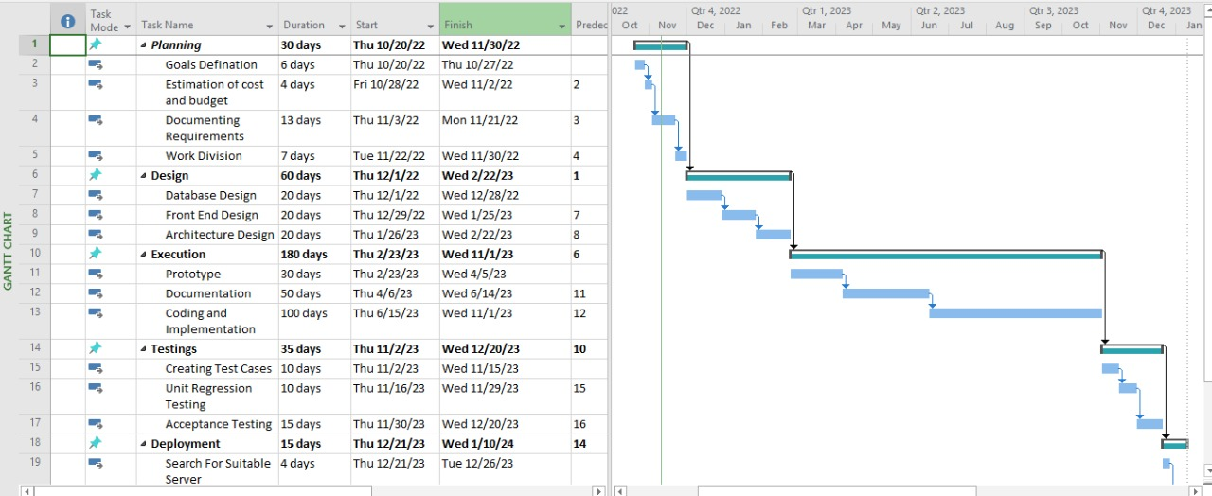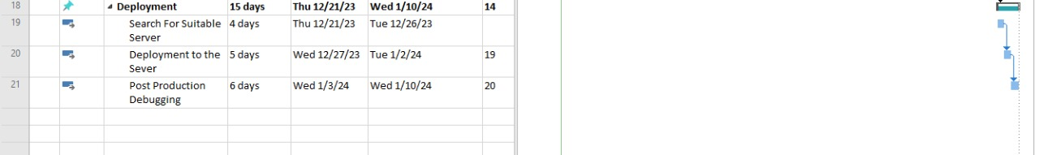

In the above WBS and Gantt Chart the arrows represent the relationship between tasks and activities as successor starts after predecessor activity finishes.

# Mockups

Insert minimum mockups (Usually 4-6 mockups) which show the major modules mentioned in the scope section of the document. **Do not include mockups for Login, Signup, Forgot Password, Contact Us, About Us etc.** If the project is a Web or a Smartphone Application, then include at-least three mockups from each part of the project.

Each mockup must give explanation about the screen.

NOTE: You can design mockup in any design tool for example pencil tool (<https://pencil.evolus.vn/>) or Balsamiq (<https://balsamiq.com/>)

Example is given in Appendix A.

# References

N/A

# Plagiarism Report

Attach the Plagiarism report of your project scope document from library staff of turnitin tool (<http://turnitin.com>)